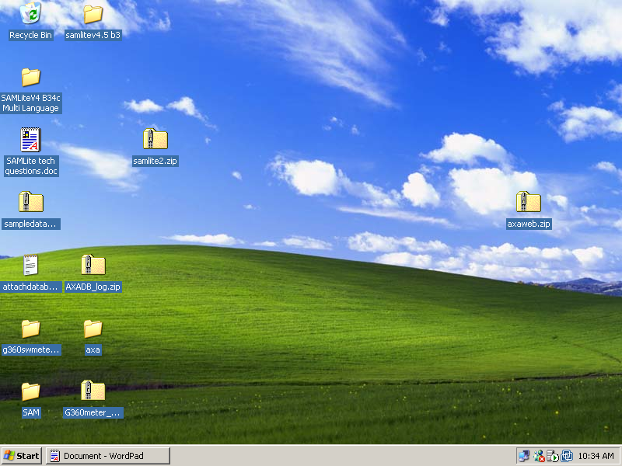
1. Extract axaweb.zip to a unique directory, eg C:\Documents and Settings\user1\Desktop\12345 where 12345 is a unique value and axaweb will be extracted to C:\Documents and Settings\user1\Desktop\12345\axaweb. This directory will be used later.

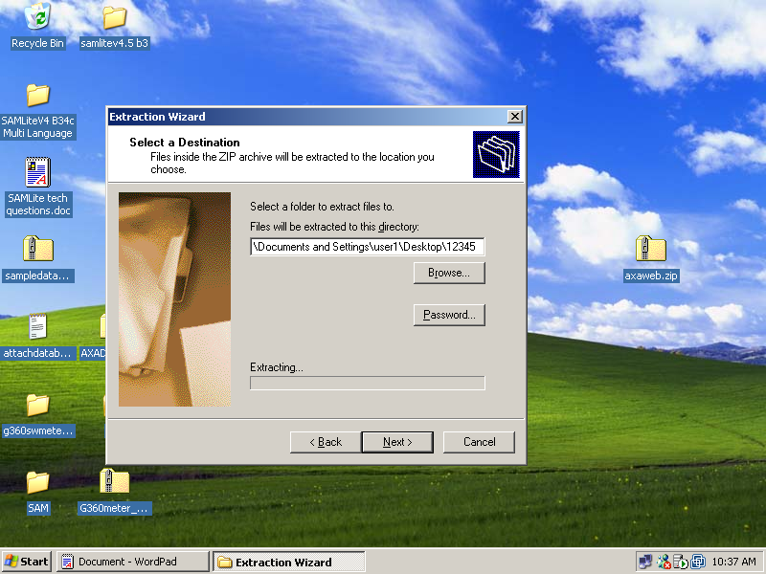

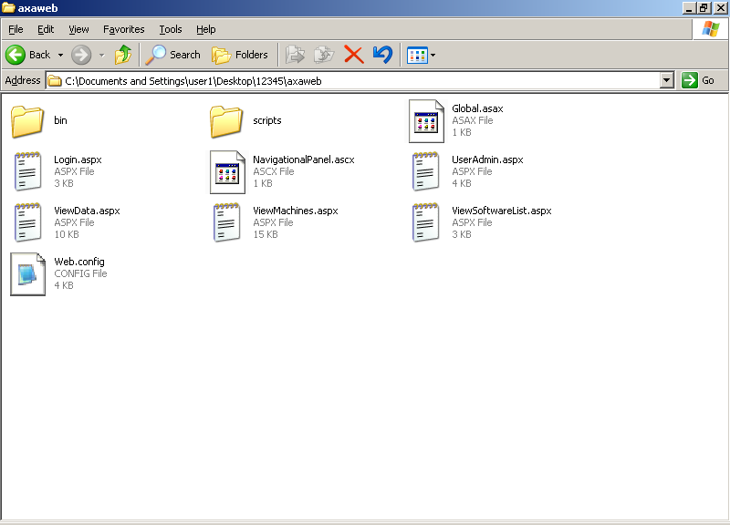

2. Open up Control Panel, and launch the Administrative Tools applet.

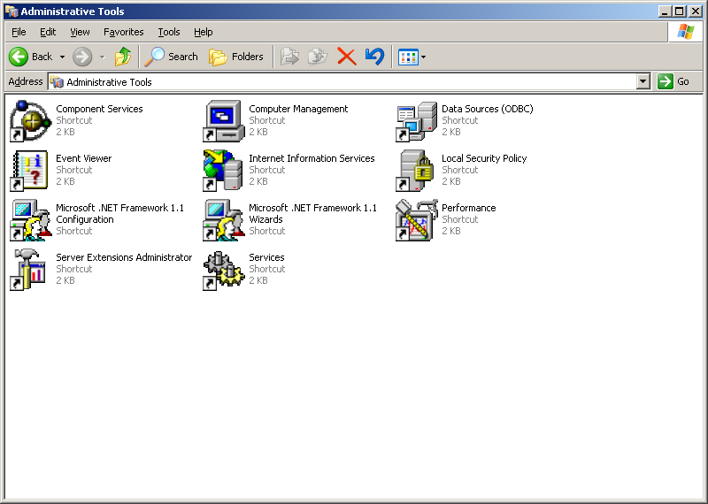

3. From the Administrative Tools applet, launch the Internet Information Services applet.

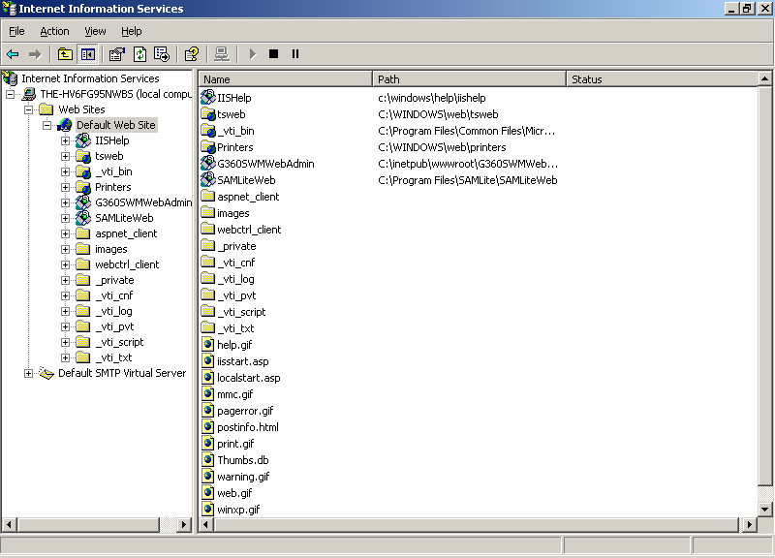

4. Browse to the current AXA web site. The name of the web site may or may not be "Default Web Site", but this does not matter. Locate the SamLiteWeb virtual directory note, and expand it by clicking on the plus (+) symbol beside it.

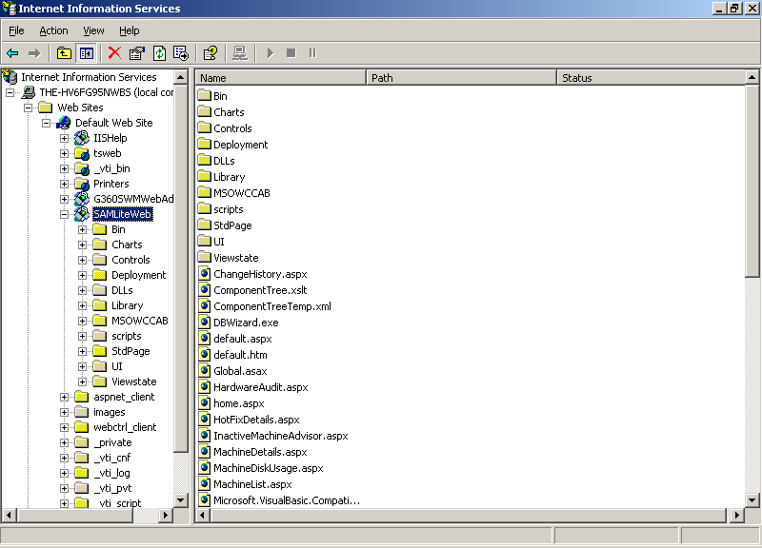

5. Right click on the SAMLiteWeb node, and select New, Virtual Directory.
6. The Virtual Directory Creation Wizard comes up.

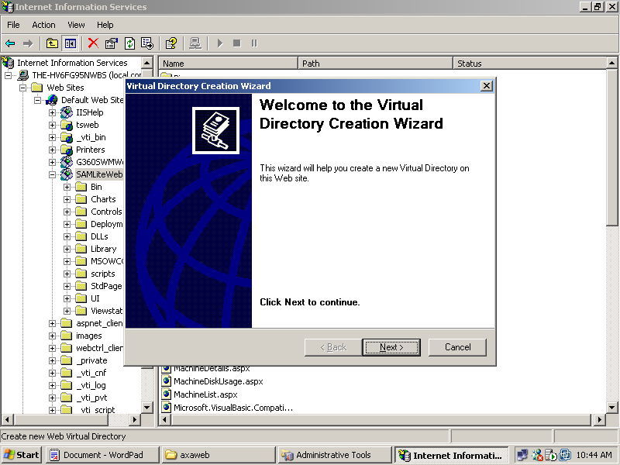

6. Click on the Next button.

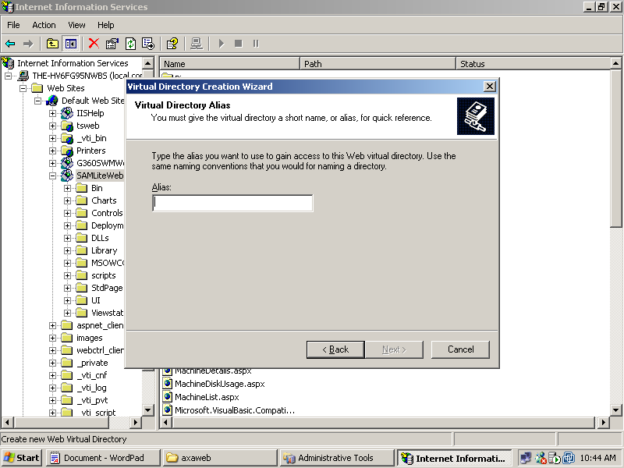

7. Enter the new virtual directory name, such as axaext or axaweb. This will be the name used to access it in future, for example, http://sitename/axaext/Login.aspx or http://sitename/axaweb/Login.aspx

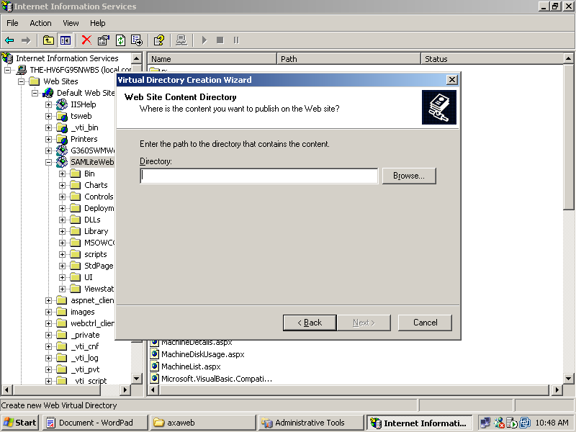

8. Point the directory field in the Web Site Content Directory to the value in Step 1, eg C:\Documents and Settings\user1\Desktop\12345\axaweb and click Next.

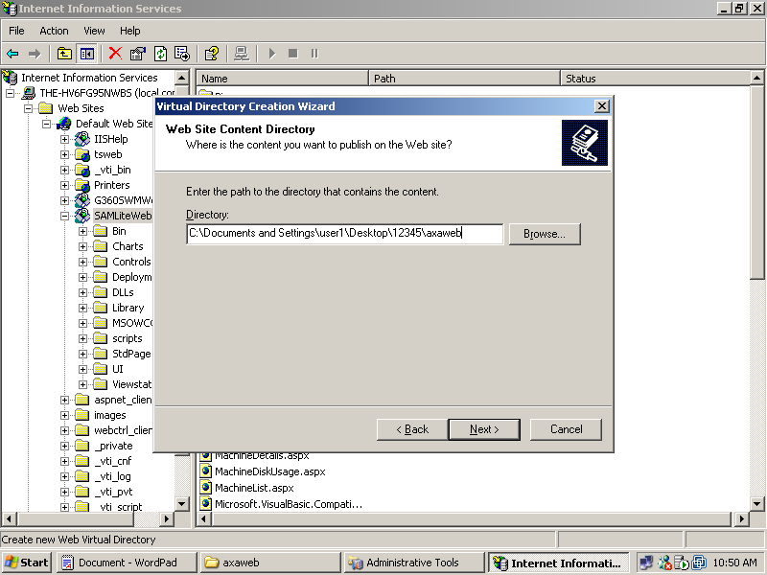

9. Click Next again on the Access Permissions screen and finally, click Finish.

10. Open up a Command Prompt by going to the Windows Start menu, Programs, Accessories, and select Command Prompt.

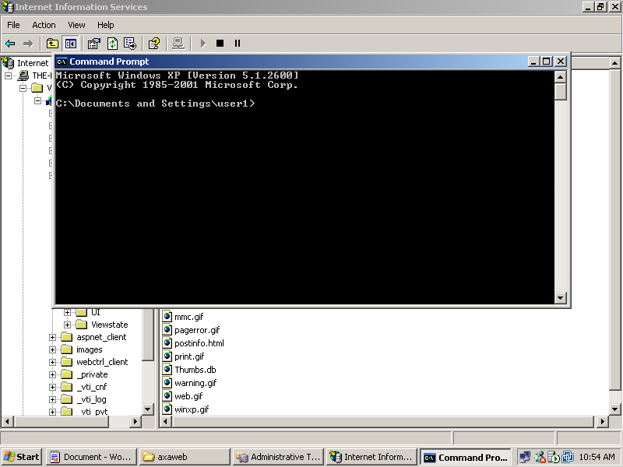

11. Run the command %windir%\microsoft.net\framework\v1.1.4322\aspnet_regiis -lv .

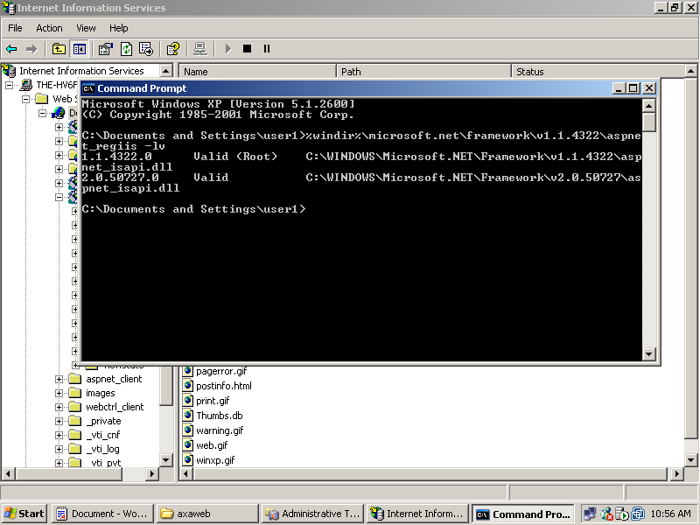

12. If there is only 1.1.4322 listed on the output screen, then run the command %windir%\microsoft.net\framework\v1.1.4322\aspnet_regiis -r.

13. Run the command, hostname and note the output value, which is the hostname. For example, the output is the-hv6fg95nwbs.

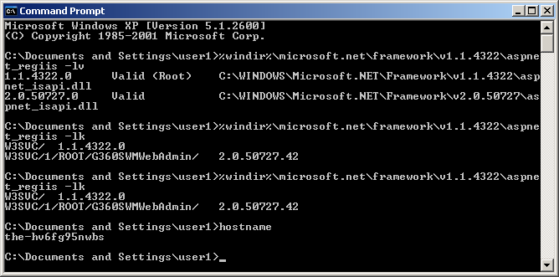

14. Go back to the Internet Information Services applet.

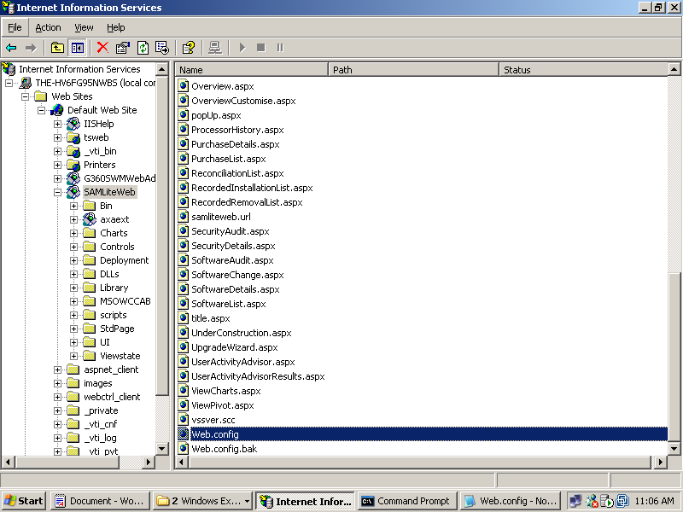

15. Right click on Web.config and select Open in the SamLiteWeb node. Locate the line that contains db.udlpath and get the value of Data Source, Initial Catalog and password.

16. From Windows Explorer, navigate to C:\Documents and Settings\user1\Desktop\12345\axaweb or the directory in Step 1.

17. Right click on the file, Web.config, and select Edit. If Edit is not available, select Open.

18. Navigate to the bottom of the file, and replace MACHINENAME with the Data Source value obtained in Step 15.

19. Scroll to the right of the file and locate databasename and dbpassword.

20. Do it similarly for databasename and dbpassword by replacing it with the values of Initial Catalog and password in Step 15 and save the file.

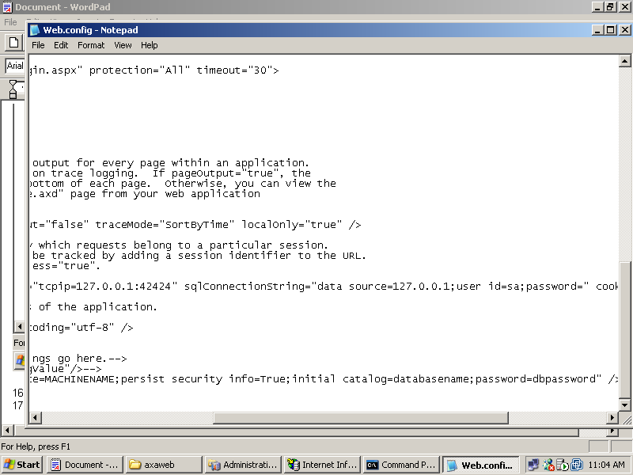

21. Right click on the Login.aspx file in the directory in Step 7. Select Browse.

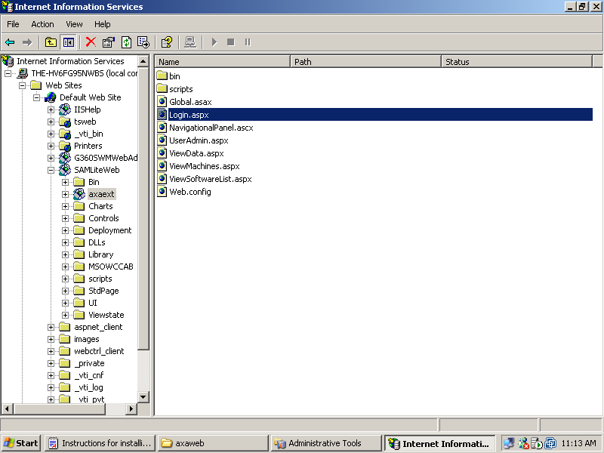

22. If all goes well, you should a screen similar to the following.

